Green Blue Deployment
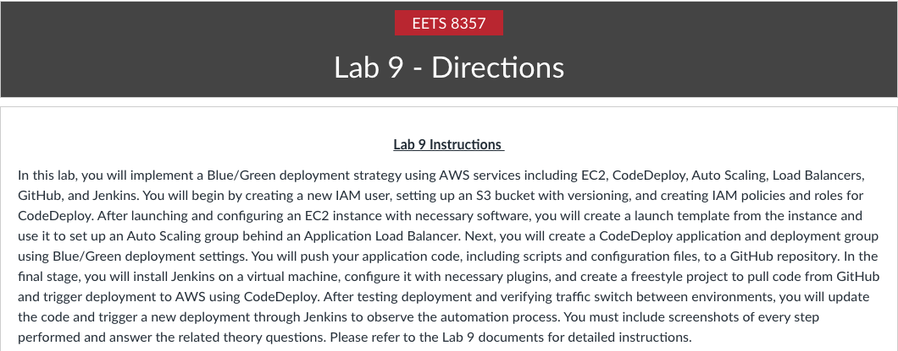
PART 1: Deploying EC2 instances (Change Region to US East (Ohio) us-east-2)
TASK 1: Start by creating a new user with following permissions and log in using that.
(ADD SCREENSHOT).
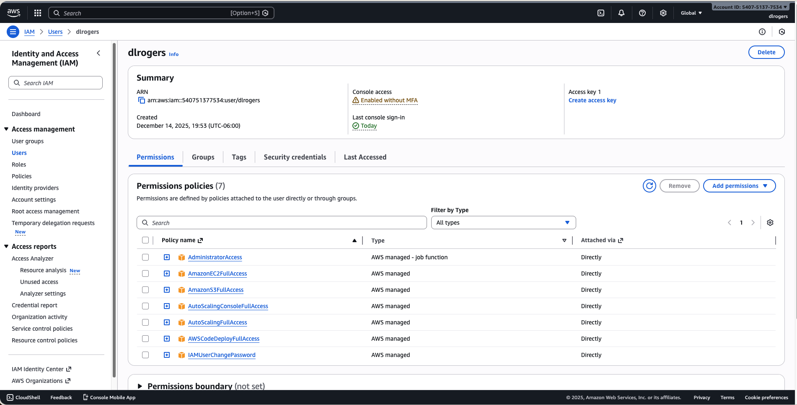
TASK 2: Create an S3 bucket <your-name-blue-green> and enable Versioning as well.
(ADD SCREENSHOT) (AWS Bucket region - Change Region to US East (Ohio) us-east-2)
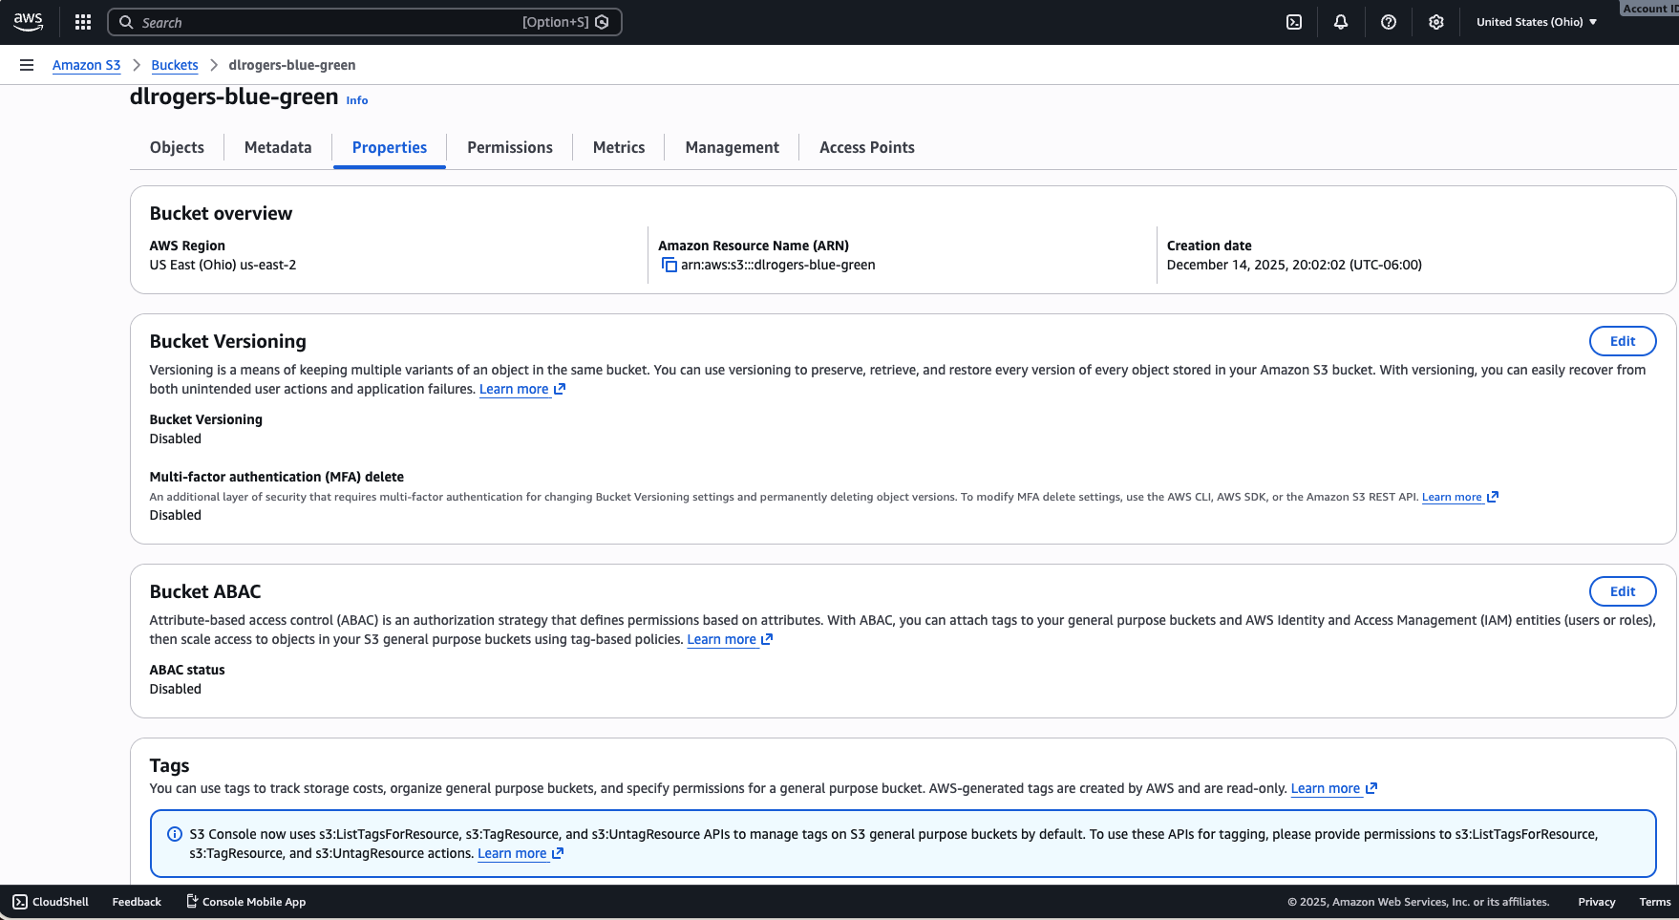
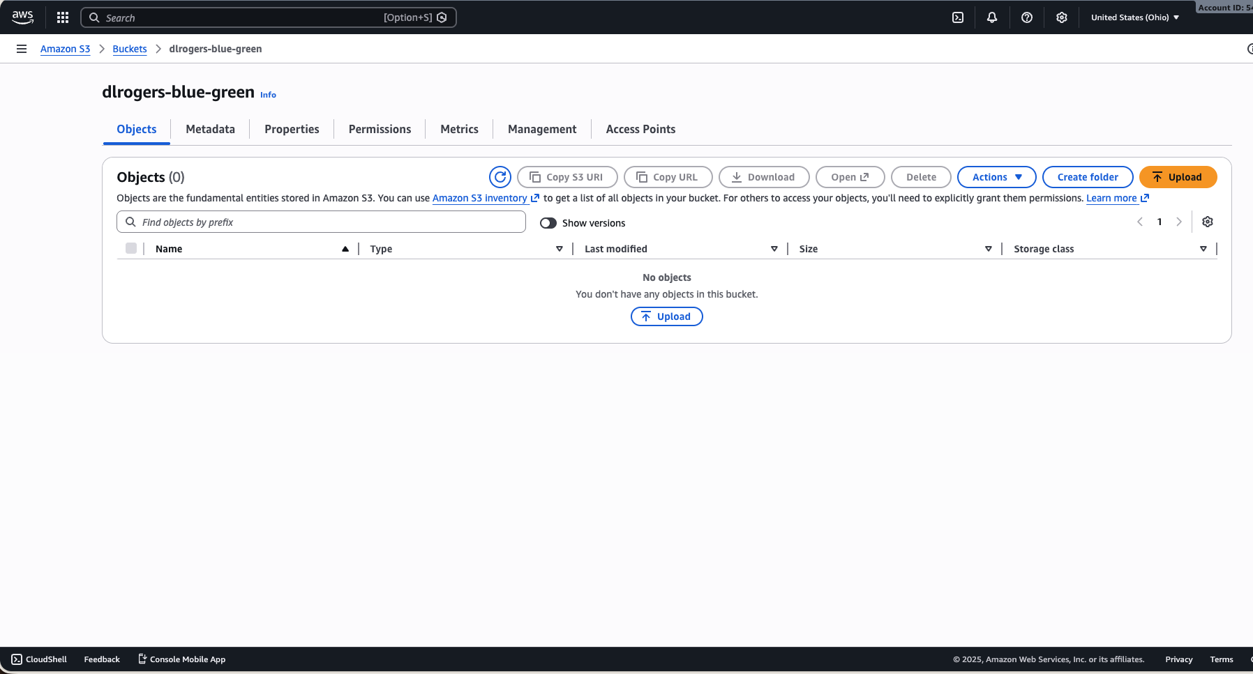
TASK 3: Navigate to IAM and create a new policy in JSON name as CodeDeployPerm and paste the following (Replace your s3 bucket name in resource).
{
"Version": "2012-10-17",
"Statement": [
{

"Action": [
"s3:Get*",
"s3:List*"
],
"Effect": "Allow",
"Resource": "arn:aws:s3:::ashish-s3-blue-green"
}
]
}
Click On Create Policy:
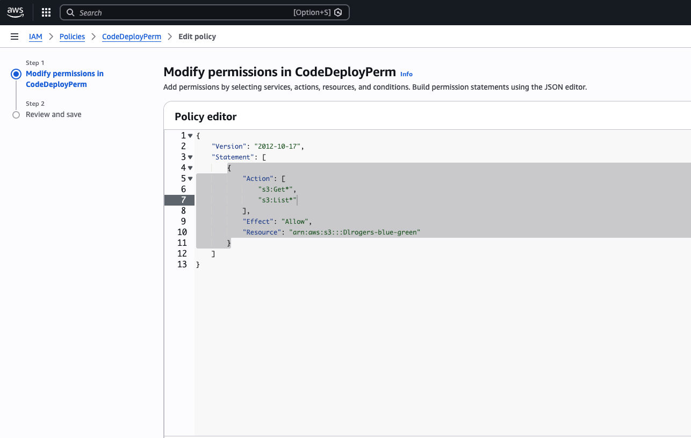

Create a new role (select EC2 service) with following policies attached and name it as
<CodeDeployEC2-your-name> (ADD SCREENSHOT).

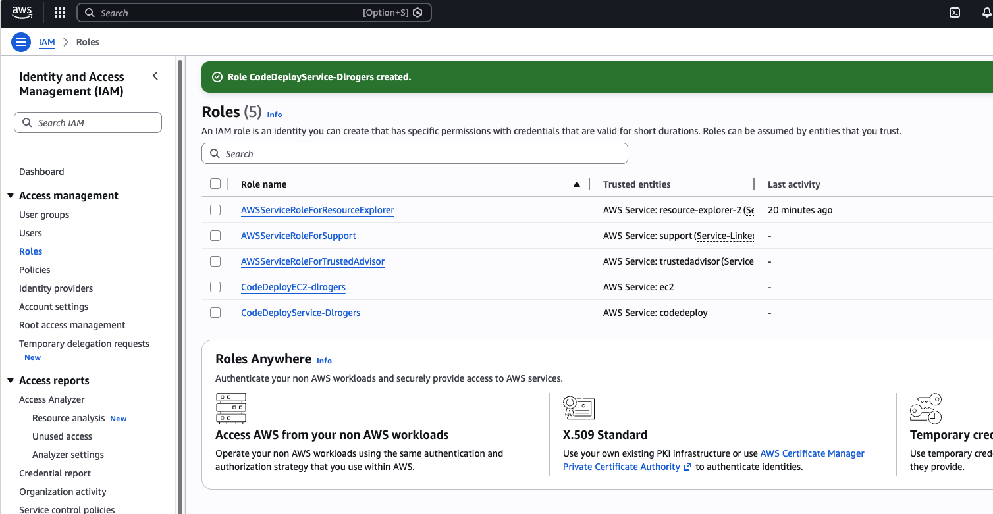

Theory question:
Q) Explain what IAM policies, roles and users are?

TASK 4: Creating EC2 instance
Name the instance as <your-name-BGlab> Create a new key-pair:
Select the newly created IAM role for EC2.
Create a new security group named as <your-name-SG> with following rules:

Put the following in User Data in as Shown:

(Make sure to change your region name in this if you are not in us-east-2)

#! /bin/bash
sudo yum update -y
sudo yum install ruby -y
sudo yum install aws-cli -y
sudo yum install httpd -y
sudo systemctl start httpd
sudo systemctl enable httpd
cd /home/ec2-user/
aws s3 cp s3://aws-codedeploy-us-east-2/latest/install . --region us-east-2
chmod +x ./install
sudo ./install auto
sudo service codedeploy-agent start
sudo service codedeploy-agent status

We are installing the dependencies required and the code deploy agent on our instance by putting the above commands in User Data. If not using User data, you can also manually log in to your instance and install the requirements.

Wait for your instance to pass status checks:
(ADD SCREENSHOT of Every Step Performed)

Log into instance using any terminal and check if CodeDeploy agent & httpd is running or not. (Add Screenshot).

TASK 5: Creating an Application Load Balancer

Step 1: Navigate to EC2 and select Load Balancers under Load Balancing and create a new Load Balancer: Select Application Load Balancer.

Select all Availability zones & Select the Security group you created earlier. Create Target Group use following Details shown in Images below.

Wait for the state to change from provisioning to active: (ADD SCREENSHOT)

Select your instance and add it to Registered Targets and create.

STEP 2: Navigate to EC2 Dashboard and create a template from your instance and name it as
<yournameTemp>: (ADD SCREENSHOT).

We are creating a template from our instance so that everything our instance has, will be present in the template and we will use this template to create an Auto-Scaling Group in next step. This group will contain everything our current instance consists of.

STEP 3: Creating an Auto-Scaling Group: (ADD SCREENSHOT)

Name the Auto Scaling group as <yournameAS> and choose the template created.
Select all the subnets:
Enable Load Balancer and select out Target group:
Select the Group size and create.

Theory questions:
Q) Explain what an Auto-Scaling group is.
Q) What happens if I were to delete any instance after creating an Auto-Scaling group.

PART 2: Creating a CodeDeploy Application

TASK 1: Create a new application named as <yourname-BG> and choose EC2/On premises as compute platform. (ADD SCREENSHOT).

TASK 2: Creating a deployment group for our CodeDeploy Application: (ADD SCREENSHOT).

Choose the service role we created for CodeDeploy in Part1.
Choose the Deployment type as Blue/Green and Auto-Scaling group we had created in Part1. Choose the ALB we had created in Part1 and create the Deployment Group.

Theory question:
Q) Explain what is a Deployment Configuration?

PART 3: GitHub

TASK 1: Create a new repository on GitHub named as <your-name-BG>
(ADD SCREENSHOT) & Your repo should look like this after Task 2 & 3:

TASK 2: Create a folder in your repo named as scripts and create 3 files in it as following: (ADD SCREENSHOT).

TASK 3: Create an appspec.yml and index.html file in your repo as following (Not inside the scripts folder) (ADD SCREENSHOT).

PART 4: JENKINS

What is Jenkins? Jenkins is an open-source continuous integration/continuous delivery and deployment (CI/CD) automation software DevOps tool written in the Java programming language. It is used to implement Ci CID Workflows called pipelines. Jenkins can be installed through native system packages, Docker, or even run standalone by any machine with a Java Runtime Environment (JRE) installed.

There are multiple Java implementations which you can use. OpenJDK is the most popular one now, we will use it in this guide.

(Make use of Virtual Machine with Ubuntu Desktop image link Provided)

In our lab, we are going to use Jenkins to create our source build and create deployment.
Installation: (ADD SCREENSHOTS).

Install openjdk-8-jdk (Java JDK) and Jenkins. Check Java and Jenkins versions.

Check Jenkins status:

Link which will help you install JDK and Jenkins on your VM or Local Machine Respectively. https://www.jenkins.io/doc/book/installing/linux/
https://phoenixnap.com/kb/install-jenkins-ubuntu

Now go to Browser on same system where Jenkins & java is installed.
Open Jenkins and create a new user of your name, set password & install CodeDeploy Plugin.

(ADD SCREENSHOTS AND EXPLAIN ALL STEPS).

TASK 1: Creating Jenkins job
Step 1: Create a new freestyle Project named as <your-name-BGlab>.
Select Source Code as Git and enter your GitHub repo URL:
Select a Post-Build job as Deploy application to CodeDeploy and enter the details.

(ADD SCREENSHOT).

Step 2: Now build your project (ADD SCREENSHOT).

Theory question:
Q) What is a Jenkins job?

TASK 4: Now go back to AWS Console and check for the deployment: (ADD SCREENSHOT).

TASK 5: Check whether traffic has been shifted:

Theory Question:
Q) Explain the role of load balancer in this scenario.

TASK 6: Now when you check all the resource that have been replaced & Attach screenshot of all.

TASK 7: Now make any changes to your index.html file and use Jenkins to trigger it.
(ADD SCREENSHOT).

Note: You can also create an Ansible playbook to trigger Jenkins job so every time a change is made, you don’t have to manually create a Jenkins job.

Also Delete every other Resources you have created for lab.

End of Lab

LAB 9 SUMMARY GREEN BLUE DEPLOYMENT

CloudFormation provides a declarative approach to managing AWS infrastructure through templates, enabling version control and automation. ​

CloudFormation Overview
- CloudFormation (CFn) is a declarative tool for outlining AWS infrastructure. ​
- It allows users to define resources like EC2 instances, security groups, and S3 buckets in templates. ​
- Resources are created in the specified order with exact configurations. ​
CloudFormation vs Ansible/Terraform ​
- CloudFormation is AWS-native and always up-to-date with AWS features. ​
- It is declarative, while Ansible and Terraform can be more complex and less synchronized with AWS updates.
Declarative vs Imperative
- CloudFormation uses a declarative approach, while AWS CLI is imperative. ​
- Running a CFn script again recognizes existing resources, while CLI may produce errors if resources already exist.
Creating AWS RDS Instance ​
- RDS instances can be created declaratively using CloudFormation templates or imperatively using AWS CLI commands. ​
- The declarative method ensures that existing configurations are recognized.
Summary of CloudFormation Workflow ​
- Templates must be uploaded to S3 and cannot be edited directly.
- Stacks are identified by static names, and deleting a stack removes all associated resources. ​
Creating S3 Bucket ​
- S3 is used for storing static files and is globally replicated. ​
- Access control lists (ACLs) can be applied to manage permissions.
Updating CloudFormation
- Updates can be categorized as replacement updates or non-interruptive updates.
- Access control and bucket naming conventions are critical for S3 buckets.
CloudFormation Template Options ​
- Common parameters include tags, permissions, notification options, and rollback configurations. ​
- Stack policies can protect resources from unintentional updates. ​
CloudFormation Designer
- A tool to visualize and draft CloudFormation templates, ensuring they are well-structured. ​
CloudFormation Building Blocks ​
- Key components include resources, parameters, mappings, conditionals, metadata, and functions.
Deploying CloudFormation Templates ​
- Templates can be deployed manually or automatically using the AWS CLI. ​
CloudFormation Parameters
- Parameters allow dynamic inputs to templates, making them adaptable to future changes. ​
- They can be controlled by various constraints, such as type and allowed values.
Resources
- Resources are the core building blocks of CloudFormation templates, representing AWS components. ​
- There are over 200 resource types available.
CloudFormation Mapping
- Mappings are fixed variables useful for differentiating between environments like Dev and Prod. ​
Pseudo Parameters
- AWS provides pseudo parameters that can be used in any CloudFormation template for dynamic values. ​
CloudFormation Outputs
- Outputs section allows for the declaration of values that can be imported into other stacks. ​
Conditionals
- Conditionals control resource creation based on specific conditions, enhancing template flexibility. ​

